**Knox Makers Badge Intro to Solder Kit Instructions**

We usually assemble circuit boards starting with the lowest profile components and work our way up to the taller, higher profile components. This board has components on both the front and the back; for ease of assembly we will solder the front components first, the back ones last.

**Start with the resistors**

With this circuit board, like most, we’ll start with the resistors. Resistors are usually labeled on schematics and circuit boards as R1, R2, R3, etc. Resistors are not polarized components so they can be inserted with either end in either hole. They are typically labeled with colored rings. This kit can be built with a wide range of resistor values so use whatever was included in the kit. All of the resistors are of the same value so any resistor can go into any position on the circuit board.

For each resistor bend its leads 90 degrees, insert the resistor from the front and bend the leads outward on the back around 45 degrees to hold it in place. Resistors should sit flush with the circuit board and hold in place when the circuit board is upside down.

You might find it helpful to go ahead and solder the resistors in place and trim the leads on the back flush so they aren’t in the way of the next components.

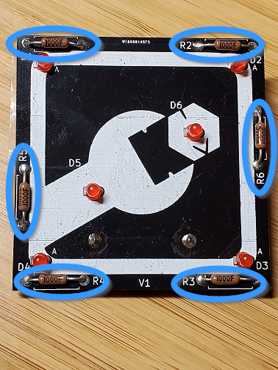

**Now the LEDs**

LEDs are a type of diode and all diodes are polarized with one lead being the anode and the other being the cathode. There are two ways to identify which lead is which on an LED. The shorter leg is the cathode, the longer leg the anode. There is also a flat side on the LED housing which indicates that side is the cathode.

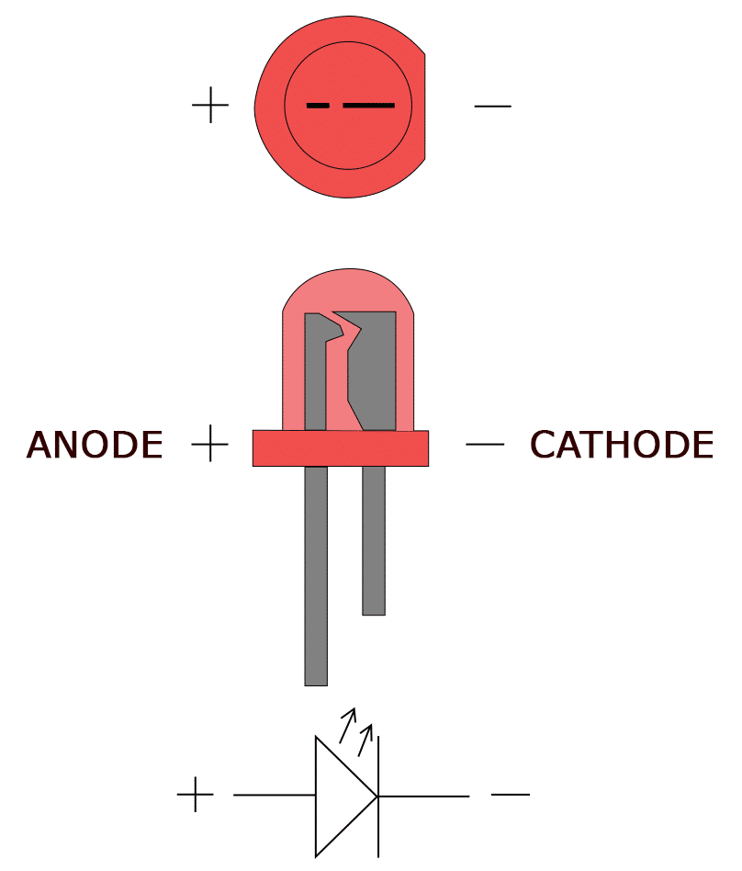

The circuit board has an “A” next to the anode lead on each diode as shown below.

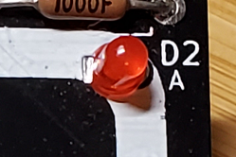

Insert the diodes, carefully noting lead polarity, bend the leads outward on the back, solder them and trim the leads flush.

**The Coin Cell Battery Holder**

The battery clip mounts on the back of the circuit board. In order for the battery to make good contact with the battery clip and the PCB, the clip should sit flush with the PCB after soldering. Being a larger piece of metal than the other components, it may take longer for the solder iron to adequately heat it up.

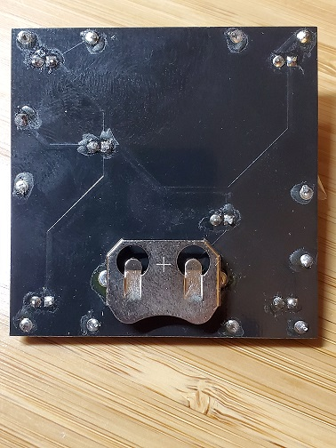

**Test and debug**

Slide the coin cell battery into its holder with the plus side up (making contact with the tabs on the cage). The LEDs should light up and then start blinking.

If no LEDs are illuminating:

* Check that the coin cell battery is inserted with the plus side up.
* Check that the battery is not dead by either swapping it with a known-good battery, or by measuring the voltage across the batter with a voltmeter.
* Check that the LEDs are not inserted backwards. The flat edge of the LED should be visible under good light and/or magnification, it should be oriented as described during the build description.

Some LEDs are illuminating:

* Reflow the solder joints on the non-working LED and associated resistor.
* Verify that any non-working LEDs are soldered with the correct orientation.

Congratulations, you did it!

**Theory of Operation**

The circuit is simply a coin cell power source which is applied across 6 parallel diode/resistor combinations. The coin cell battery provides a 3V power source to the circuit. The LEDs contain internal circuitry that causes them to flash. The resistors are not required with these LEDs; the LEDs themselves manage their current flow. The resistors are simply included in order to prevent one faulty LED from preventing the other LEDs from functioning.

**Schematic**

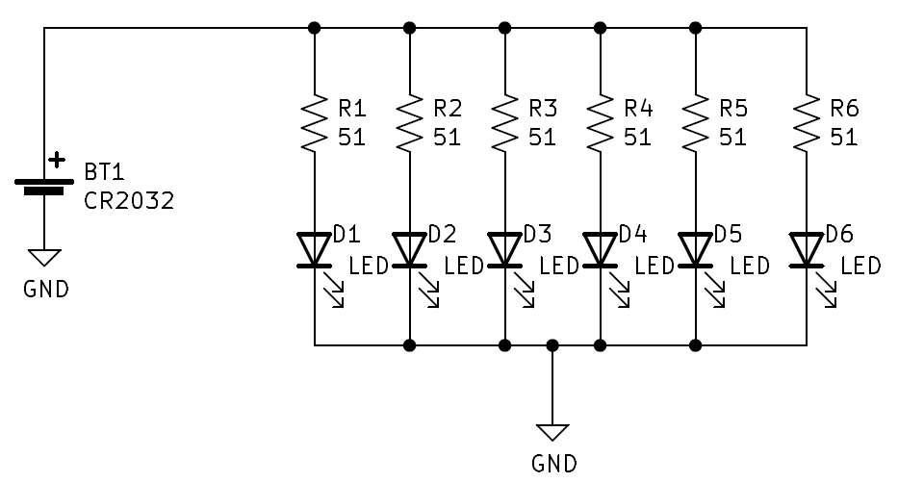

**Layout**

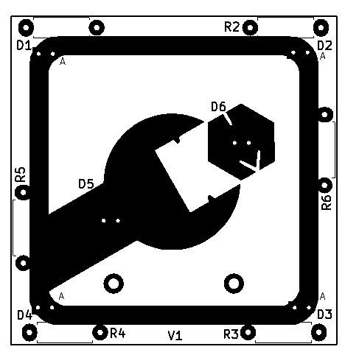

**Bill of Materials**

|  |  |  |
| --- | --- | --- |
| **Qty** | **Designator** | **Item** |
| 1 | - | PCB |
| 1 | J1 | Coin Cell Battery Holder |
| 6 | R1-R6 | Resistors |
| 6 | D1-D6 | 3mm flashing LEDs |